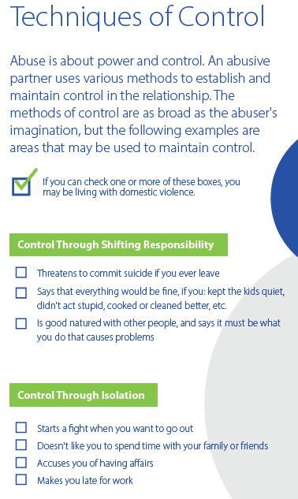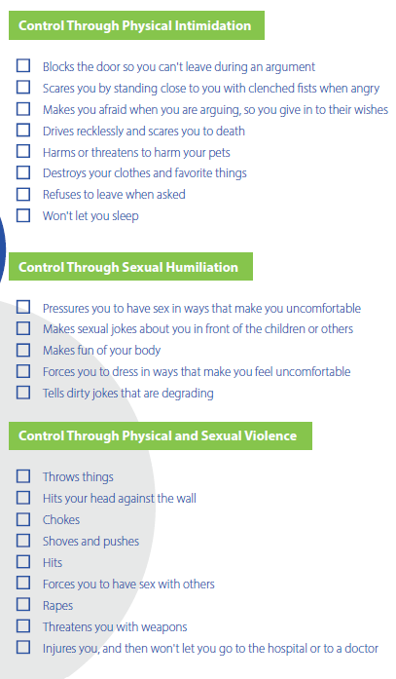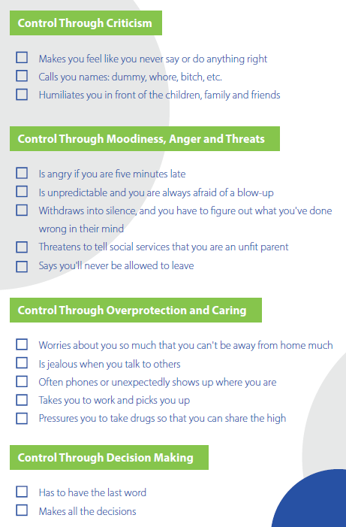

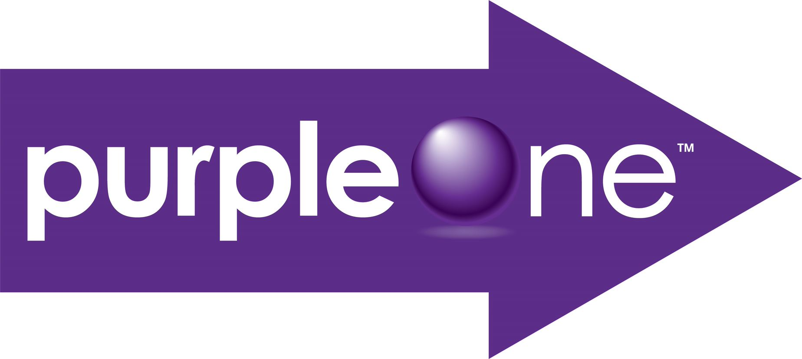

Access online at: [**https://www.mysafejourney.org/resources/am-i-being-abused-quiz/**](https://www.mysafejourney.org/resources/am-i-being-abused-quiz/)

For more information or questions call [Insert your Agency Name and Phone Number]